Contact Management App

# Introduction

ReactJS is a JavaScript library for building user interfaces, it allows for reusable UI components and efficient updates with virtual DOM.

TypeScript adds optional type checking to improve code structure and catch errors.

Tailwind CSS provides a set of pre-defined CSS classes that can be used to quickly and easily style elements.

Chart.js is a JavaScript library for creating charts and graphs. It is simple to use and has a wide range of chart types, including bar charts, line charts, and pie charts.

Redux manages application state and allows for easy data updates and organization.

Together, these tools provide a powerful and efficient development experience.

# Pre-Requisite

|  |  |
| --- | --- |
| Tools | Usage |
| Node.js | Make sure to have the Node.js installed & running in your computer. If you already have installed Node on your computer, you can skip this step if you have pre-installed Nodejs. |
| Git | Make sure to have the Git installed globally & running on your computer. If you already have installed git on your computer, you can skip this step. |

# Steps for installation

1. Open the command prompt.
2. Clone the **contact-manager** project from Github to your local machine by running the command git clone https://github.com/doubtcrack/contact-manager.git in your terminal.
3. Change into the project directory by running the command cd contact-manager.
4. Run the command npm install to install all the necessary dependencies for the project.
5. Once the dependencies are installed, you can start the development server by running the command npm start. This will start the server and open the application in your default browser.
6. Th application should be running on [**http://localhost:3000/**](http://localhost:3000/)**.**
7. Now you are able to interact and make changes to the project.
8. Once you are done with the changes, you can run the command npm run build to create a production-ready version of the application.
9. you can now deploy the build folder to your server.

Note: Make sure to check the **package.json** file for any additional setup or customization instructions.

# Overview

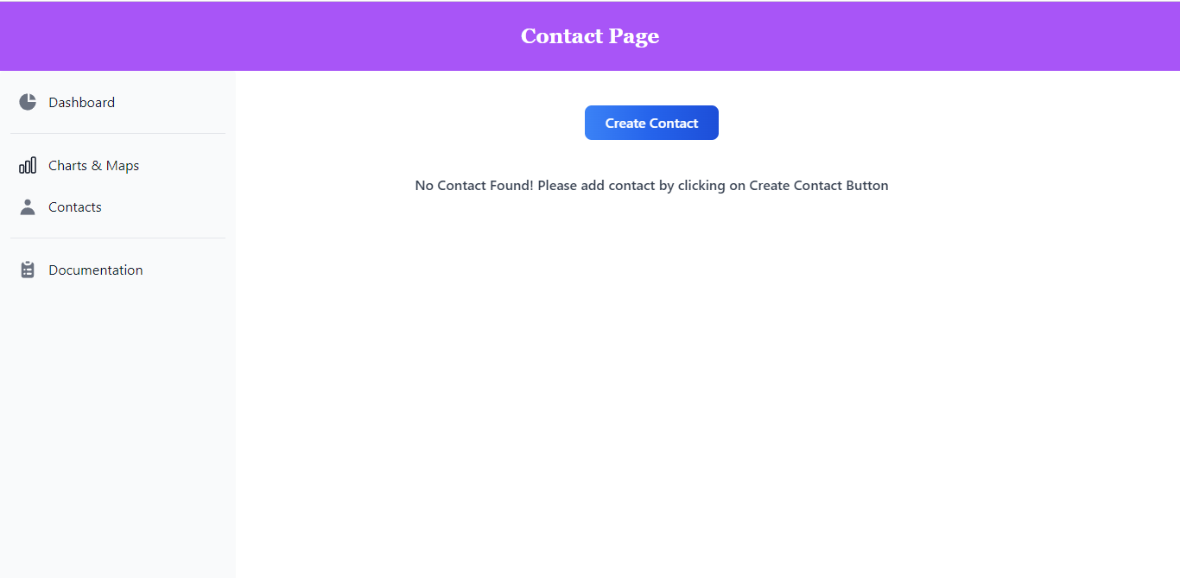

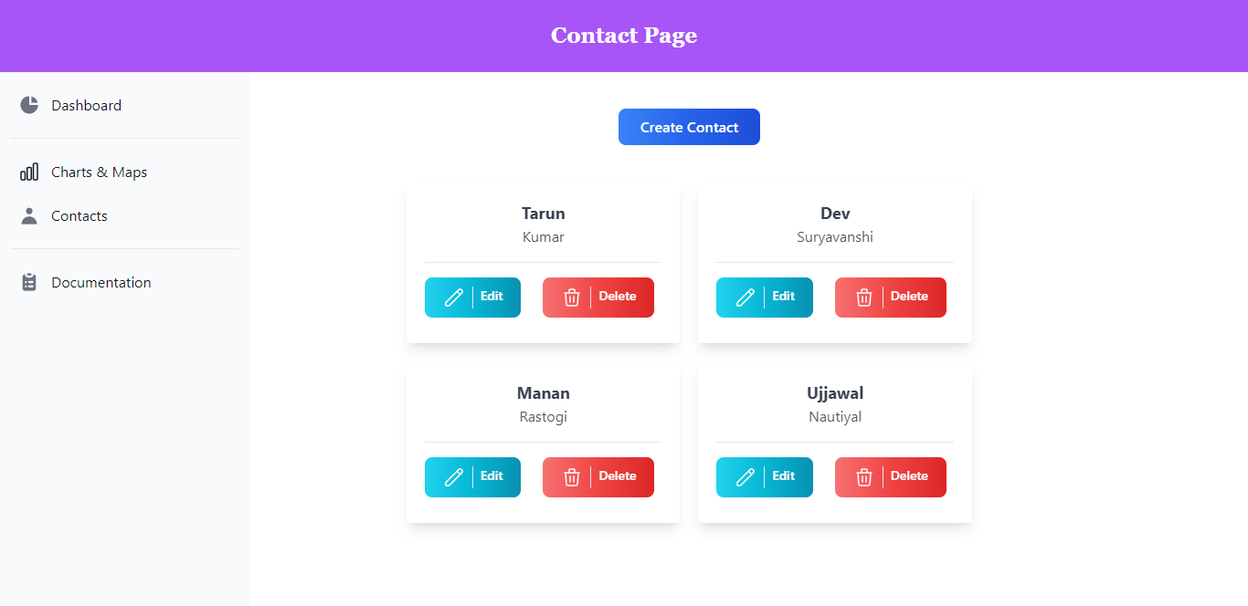

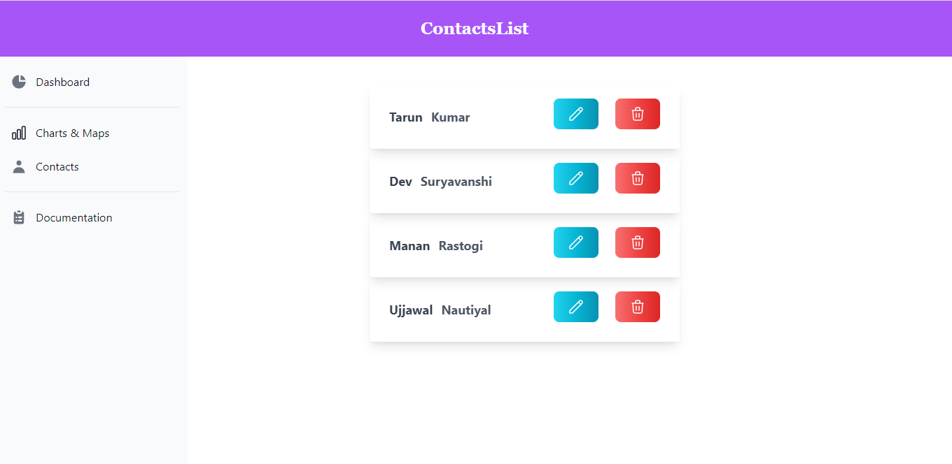

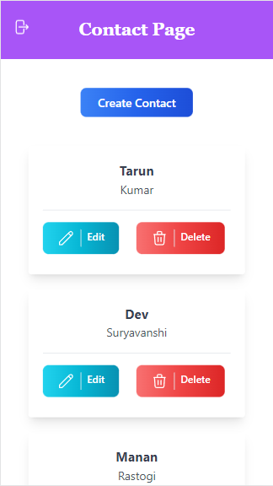

# Important Links

* **Live Version** of Site: <https://contact-manager.devbits.tech/>
* **Source Code**: <https://github.com/doubtcrack/contact-manager/>
* **Documentation** (web format): https://contact-manager.devbits.tech/Documentation/